Mechanical Overview

Year: 2017 Semester: Spring Team: 12 Project: Guitutar

Creation Date: ­2/10/17 Last Modified: May 1, 2017

Author: Jennifer Isaza Email: jisaza@purdue.edu

Assignment Evaluation:

|  |  |  |  |  |
| --- | --- | --- | --- | --- |
| **Item** | **Score (0-5)** | **Weight** | **Points** | **Notes** |
| **Assignment-Specific Items** | | | | |
| **Commercial Packaging Analysis 1** | 5 | x2 | 10 |  |
| **Commercial Packaging Analysis 2** | 4 | x2 | 8 | See comments |
| **CAD Model Illustrations** | 4.5 | x4 | 18 | Need dimensions |
| **Project Packaging Specifications** | 5 | x2 | 10 |  |
| **PCB Footprint Layout** | 5 | x2 | 10 |  |
| **Writing-Specific Items** | | | | |
| **Spelling and Grammar** | 5 | x2 | 10 |  |
| **Formatting and Citations** | 3 | x1 | 3 | Citations missing, indentation in 3.0, template changes |
| **Figures and Graphs** | 4 | x2 | 8 | Label and number all figures |
| **Technical Writing Style** | 5 | x3 | 15 |  |
| **Total Score** | 92/100 | | |  |

5: Excellent 4: Good 3: Acceptable 2: Poor 1: Very Poor 0: Not attempted

Comments:

In general, this is a fantastic analysis. I think you should take a stab at why your project solves the drawbacks of the product and project you compared your project against. Other than that, only little corrections are needed!

1. Commercial Product Packaging

We compared two products to Guitutar that are electric guitars with LED capabilities. These products were another senior design project by Andrew Garza and the Fretlight electric guitar.

* 1. Product #1

This particular design is not in commercial production, but was found on YouTube as Andrew Garza’s senior design project [1]. His electric guitar design is controlled by an Arduino that uses an Atmel AVR ATMega to control his LED matrix. He takes the fretboard and frets off the guitar neck, drills holes for each discrete LED and each fret “push button”, and then solders the LEDs together in a matrix form.

Figure 1: Fretboard Alternative

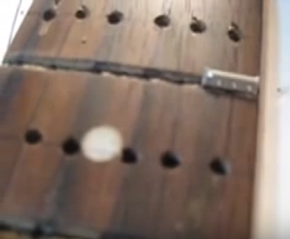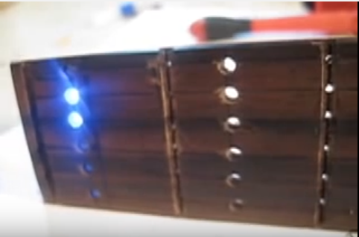

Comparatively to our design, we will not be cutting the frets to make push buttons and we will have surface mount LEDs that will be controlled by a shift register. Using the shift registers will decrease the amount of input pins we will have to use. Although we will be removing the fretboard from the guitar neck, we will not be milling the actual fretboard. Instead, we will be using the PCBs as the fretboard itself with a plastic covering to protect the electronics. The frets will be glued to the acrylic covering and will then connect through the side of the PCB with wire instead of being cut into buttons.

The Arduino and user interface for Andrew’s design is placed on the front of the guitar, and the microcontroller for the LEDs is placed on the back of the guitar [2]. The Arduino has a shield on top for the user interface that consists of a digital display and three push buttons for his three settings: Chords, Scales, Song Builder. His Chords setting displays any version of chord with the LEDs once selected, and the Scales setting displays any selected scale with LEDs. Song Builder allows the user to input up to 20 different chords that the user can make into a song.

Figure 2: Alternative User Interface

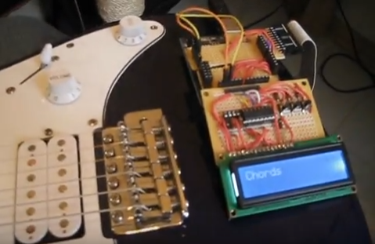

* 1. Product #2: Fretlight Wireless Guitar

The Fretlight [3] guitar is more similar to the original idea of Guitutar. Both have an app for the user interface that connects through Bluetooth and both have a USB charging port for a Lithium-ion battery. While most of the outer features are similar to ours, the company does not explain how the LEDs or the strumming patterns work inside. One idea that we will change from Fretlight is the light-up nut that indicates which open strings should be played. Since our nut is opaque and would not show LEDs through, we will have a row of LEDs next to the nut as an indication of open strings that should be played. We will also include an ON/OFF button that can be included near the USB charging port, similar to Fretlight. One of the downsides to Fretlight is that they seem to expect a certain level of experience from the user. Fretlight is especially beneficial for experienced players who are looking to do improvisation or who can already play along with songs in a real time mode. As a resolution to Fretlight’s expectations for experience, we emphasize the user mode so that any player is able to go at their own pace. The next LED progression lights up only when the user has strummed and fingered the correct notes.

Figure 3: Fretlight Guitar Example

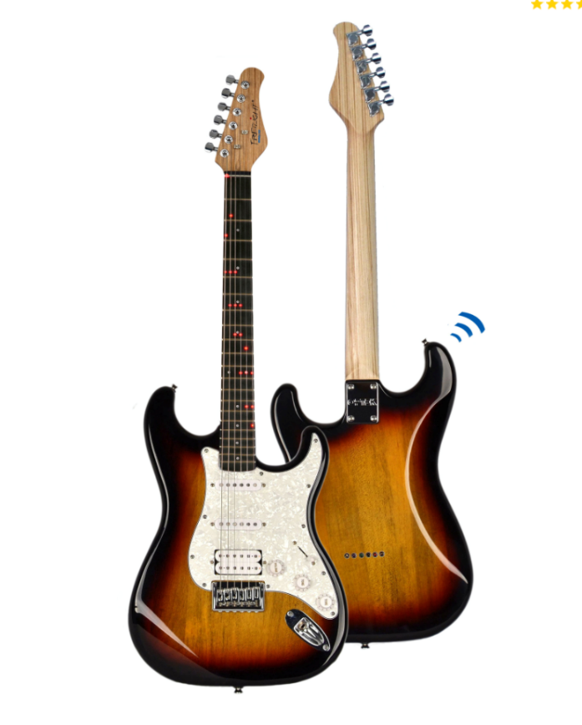

3.0 Sources Cited

[1] A. Garza, (2011, April 16). *GuitArduino Senior Design Project*. [Video]. Available:  <https://www.youtube.com/watch?v=B2s5c1RcswA&t=3s>

[2] A. Garza, (2011, April 5). *GuitArduino Update April 5 2011*. [Video]. Available:

<https://www.youtube.com/watch?v=hd-d87yq7kg>

[3] Fretlight Wireless. *FG-621 Wireless Guitar.* [Online]. Available:

<https://fretlight.com/collections/guitars>

Appendix 1: CAD Model Illustrations

**Measurements in inches

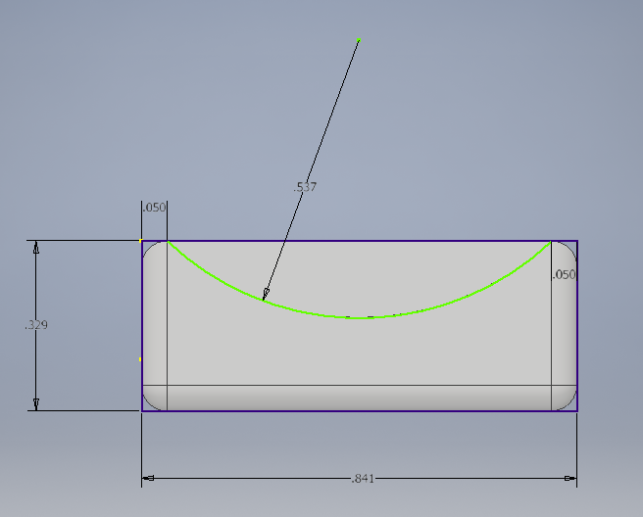

Figure 4: Front view of PCB mount

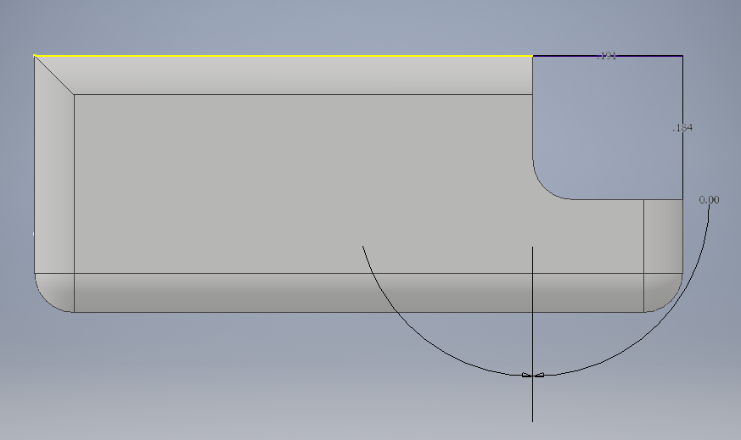

Figure 5: Side view of PCB mount

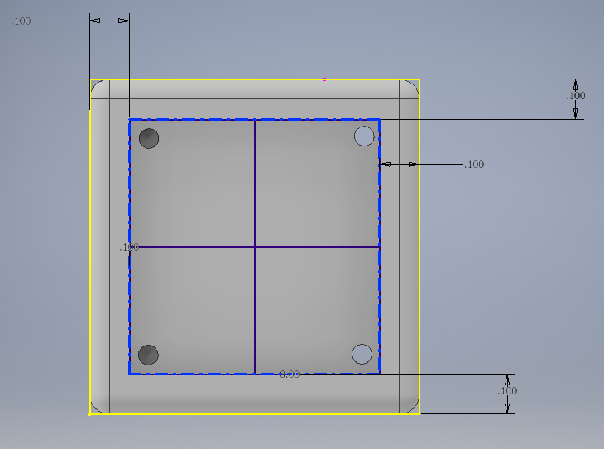

Figure 6: Bottom view of PCB mount

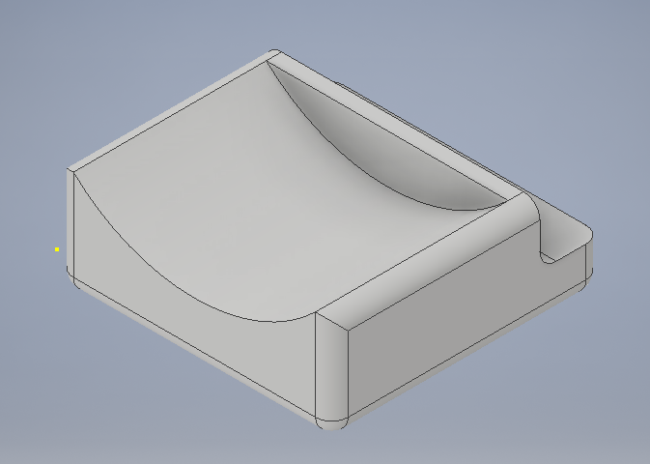

Figure 7: Isometric view of PCB mount

3D printed PCB mount modeled in Autodesk Inventor Pro:

Placed near body on back side of guitar neck. Attached by glue.

Dimensions in screenshot were auto-converted to inches from millimeters.

Length 21.05mm x Width 21.05mm

Curve has a radius of 5.36mm

Recessed section in the back is to compensate for the slope in height from the neck to the body. Slope height is 4.68mm.

Recessed section on bottom for PCB: 0.05mm from the edges, 0.1mm depth (depth may change depending on total height of PCB).

**Appendix 2:  Project Packaging Specifications**

|  |  |  |  |  |
| --- | --- | --- | --- | --- |
| Materials | Purpose | Tooling Requirements | Estimated Weight (oz) | Estimated Unit Cost ($) |
| PLA | PCB mount | 3D printer | 2.00 | 5.00 |
| Acrylic sheet | Neck cover | Dremel, Laser cutter | 6.00 | 20.00 / sheet |
| Glue | Attach PCB mount to neck | Hot Glue gun | 0.50 | 0.50 to adhere  3.00 / package |
| Screws | Attach PCB to mount | Screwdriver | 0.50 | 1.54/bag of 4 |
| Velcro | Attach PCB to neck (can use hot glue as alt) | Scissors | 1.00 | 18.00 for 10ft |
| String Sleeves | Isolate strings from shorting battery | Scissors | 0.20 | 4.25 |

Table 1: Project Packaging Materials, Weight, Cost, and Tooling

Appendix 3: PCB Footprint Layout

